**Virtual Terminal Guide**

Customization 2

Recurring Billing 4

Batch Upload 6

Gateway Options 7

Reports 11

Certify PCI™ 15

QuickBooks™ 16

Integration 16

iSpyFraud™ 16

Easy-to-use Management Tools 16

Complete Protection 16

# Customization

Required fields and adding/deleting fields.

**Step 1:** Merchants can add or delete non-required fields by clicking the **wrench.**

***Note****: fields with red asterisk are required.*

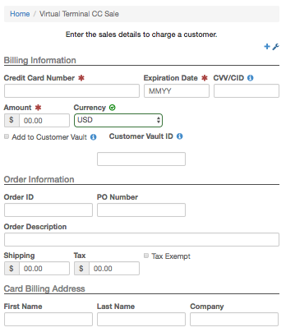

**Step 2:** Additional fields are pulled up. Toggle the fields on or off by clicking the **boxed X.** Click the **disk** to save changes.

­­

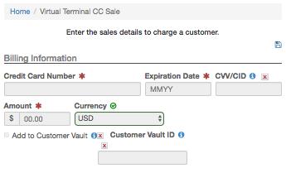

***Note:*** *there are up to 20 merchant definable fields available for the virtual terminal. The fields are cascaded through the virtual terminal and reporting functions (options > settings > merchant defined fields).*

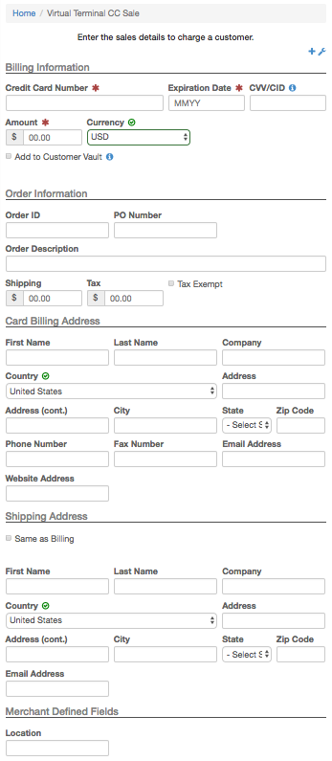

# 

# Recurring Billing

Establish recurring billing for a single cardholder or create billing plans that enable the merchant to manage an unlimited number of card holders per plan for checking accounts or credit cards.

**Step 1:** Select the type of recurring transaction.

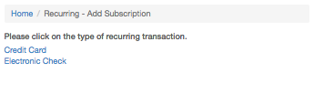

**Step 2:** Enter customer information.

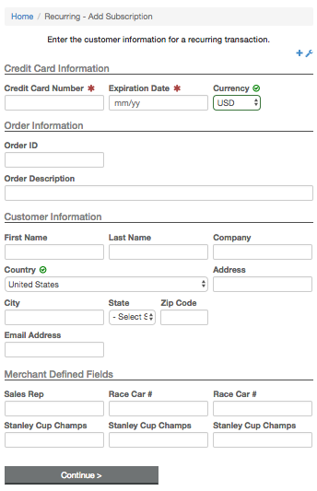

**Step 3:** Clickthe **Click Here** link to create a new billing plan**.**

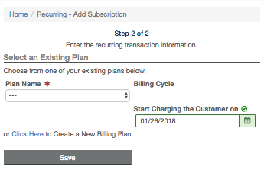

**Step 4:** Recurring billing plan creation settings. The gateway can notify the merchant with credit cards that will expire in the next 30 days on the first of each month.

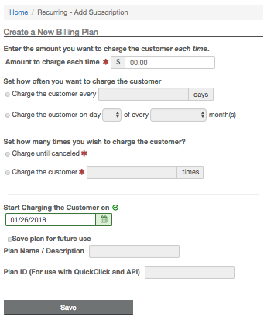

# 

# Batch Upload

Merchant can import a .CSV, .XLS or .TXT file for manually processing large amounts of transactions. The program will create 16 parallel threads that will simultaneously process transactions (50,000 transactions can be processed within 90 minutes).

**Features**

Batch program will provide auto-detection of file formats. Ex: XX.XX as dollars, 14-16 digits as a credit card, etc. Batch formats can be saved for future use.

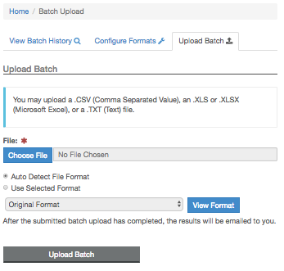

# Gateway Options

Various options that make Virtual Terminal customizable for your needs.

**Gateway Options Main Menu**

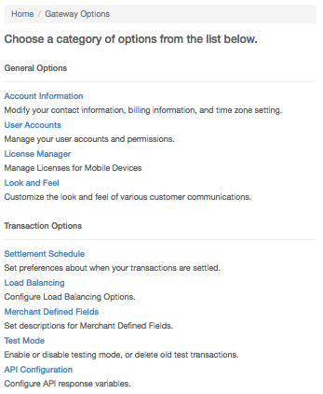

**Merchant Defined Fields**

There are 20 merchant defined fields available for use. These fields will cascade into reporting sort and search options.

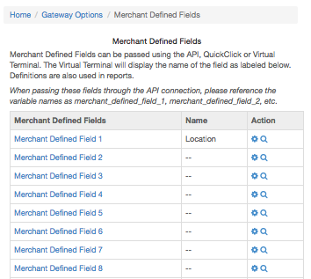

**AVS Settings**

This page will allow merchants to set rules about accepting transactions that return with address-specific return codes. They can choose to reject transactions that may contain suspicious activity.

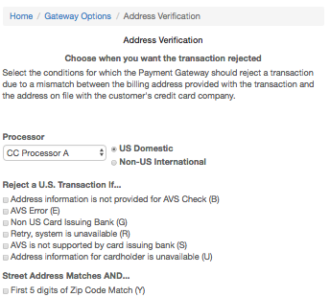

**CVV Settings**

This page will allow merchants to set rules about accepting transactions that return with CVV-specific return codes. They can choose to reject transactions that may contain suspicious activity.

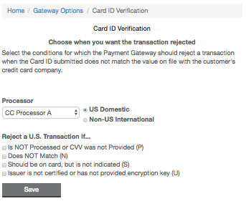

**User Accounts**

Create and manage sub-users with customer permissions and notification levels.

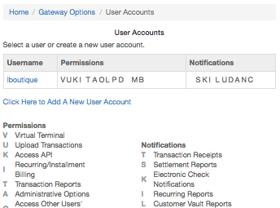

**Load Balancing (ATRI)**

Patent pending intelligent transaction routing from a single merchant to multiple processors. Ex: merchant requires $100,000 per month. Processor A will only approve $50,000. Two additional processors can be added, B and C for $25,000 each. Transactions will be intelligently routed by dollar amount or percentage. For more information on setup, refer to the ATRI Guide.

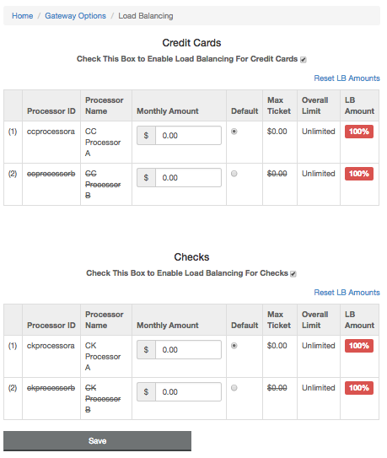

# Reports

Extensive report search and mining capabilities.

**Search Transactions**

For specific transactions by any of the default or merchant defined fields.

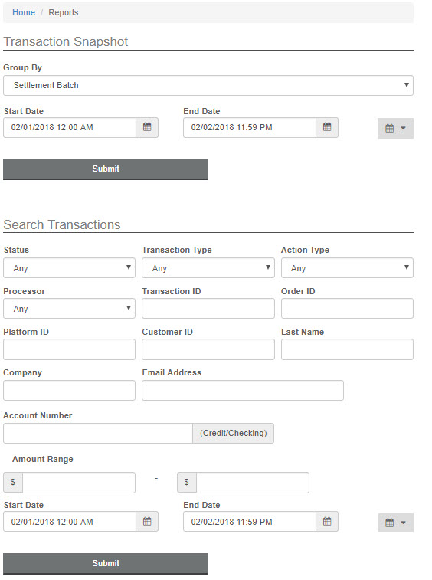

**Create Transaction Snapshot**

Enter the date range to generate the transaction report.

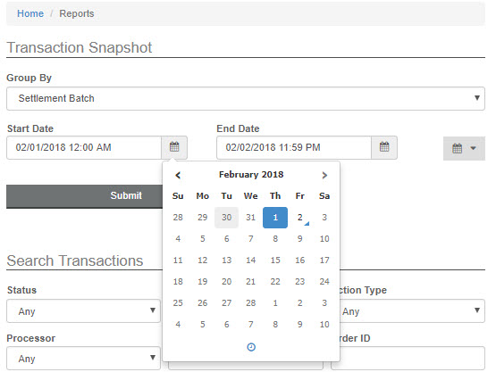

**Transaction Snapshot**

This week’s transaction summary snapshot is presented. Click on the **magnifying glass** to continue specifying the report results.

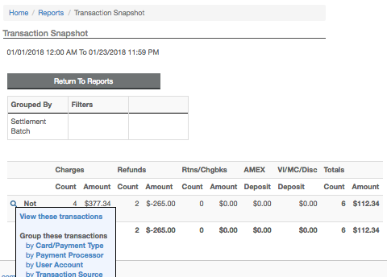

**Sort Options**

Results re-sort by credit card type.

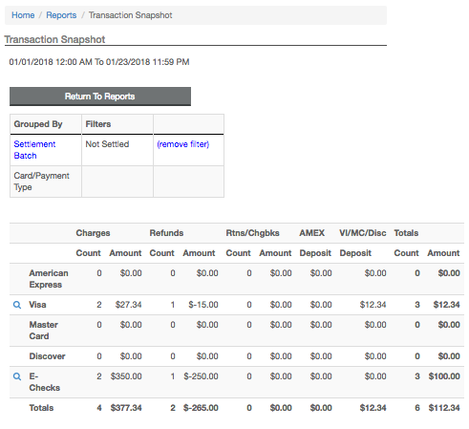

**Mining Feature**

Select **View these transactions**.

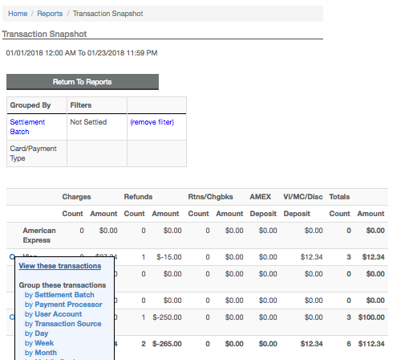

**Transaction Report**

Transactions are presented in the Transaction Report. Click the **blue ID** to display the single transaction details.

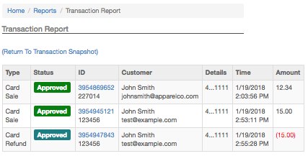

**Transaction Detail**

When viewing the transaction details, the user can elect to **Email** or **Print** a receipt, **Void** a non-settled transaction and authorize a new charge. Select **Sale** and the merchant can charge this cardholder with a duplicate order to enter a new credit card and/or dollar amount to charge without having to obtain any additional information.

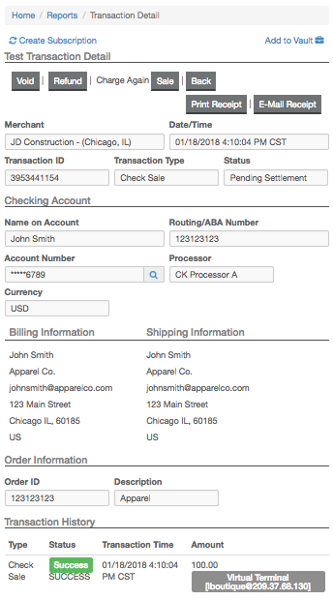

# Certify PCI™

CertifyPCI™ was designed specifically to streamline the PCI Certification process in an effort to help merchants easily achieve a higher level of security. It is an automated, web based process to PCI certify qualified merchants in minutes. $50,000 per occurrence Merchant Breach Insurance available, transparent product offering to your customers, assistance with Self Assessment Questionnaire (SAQ), Vulnerability Scanning including unlimited scans, downloadable PCI Certification Report.

**New Merchants**

New merchants will need to answer the Self Assessment Questionnaire to begin certification.

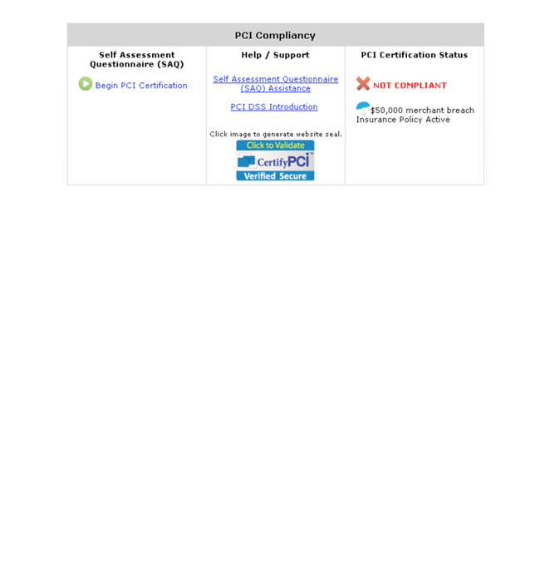

**Returning Merchants**

Retuning merchants will need to answer the Self Assessment Questionnaire yearly to maintain compliance.

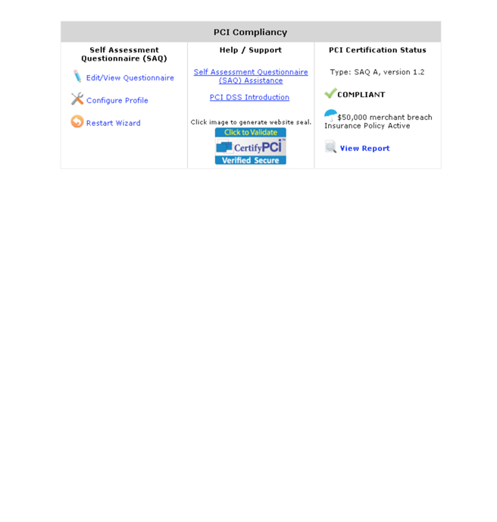

# QuickBooks™

* Link allows the merchant to export gateway transactional information   
  into QuickBooks™.

# Integration

* API documentation, shopping care references, Quickclick (shopping   
  cart included with the gateway and programming examples).

# iSpyFraud™

* A rule-set based fraud management utility that allows merchants to   
  configure extensive filters to help them in detecting fraud and screening suspicious transactions.
* Extensive reporting system gives merchants a quick and easy way to review transactions, block suspicious activity and zero in on malicious users.
* Looks at transactions both before and after processing and can decline transactions before and after authorization.
* The successful implementation and reduction in chargebacks across numerous merchants has been a testament to the effectiveness of this product.
* Example parameters are: 1. If a user charges credit card over [2] times for [Attempted] transactions, then [Deny Transaction]. 2. If daily [Attempted] transaction count for Credit Card exceeds [3], then [Flag for Review].

# Easy-to-use Management Tools

* iSpyFraud™ management tools give merchants quick and user-friendly control over their online fraud security system.
* Control Panel allows merchants to maintain their own good and bad customer list, edit filters, restrict access by banning IPs and set up and maintain filter controls. Possible filtering criteria include but are not limited to: IP Address, Email Address, Transaction Count, Dollar Amount, IP Velocity check, Dollar Velocity check, Country, US/non-US IP Ban and much more.

# Complete Protection

* Properly set fraud filters eliminate the majority of fraudulent transactions  
  in real time. The selected filters can be customized for each merchant,   
  which are continuously updated to keep the merchant one step ahead   
  of the fraudsters.